MEASUREMENT AND GEOMETRY

<___question>

Type=1

<_block>

Which of these cannot be used to prove*▲ABD ≡ ▲CDB* ?

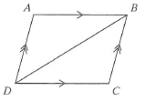

<_block>

[A] $AAS$

<_block>

[B] $SAS$

<_block>

[C] $SSS$

<_block>

[D] $RHS$

<_block>

[D]

<___question>

Type=1

<_block>

If a cone has a diameter of *10cm* and a slant height of *12cm*, what is its perpendicular height ?

<_block>

[A] $2\sqrt{11cm}$

<_block>

[B] $\sqrt{89cm}$

<_block>

[C] $\sqrt{119cm}$

<_block>

[D] $13cm$

<_block>

[D]

<___question>

Type=1

<_block>

What is the bearing of *A* from *B* ?

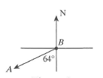

<_block>

[A] $064°$

<_block>

[B] $134°$

<_block>

[C] $206°$

<_block>

[D] $244°$

<_block>

[D]

<___question>

Type=1

<_block>

Using *S* =2 $πh$, which of these is closest to the curved surface area (*S*) of the cylinder ?

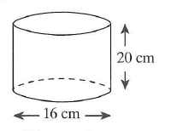

<_block>

[A] $1005cm²$

<_block>

[B] $1634cm²$

<_block>

[C] $1684cm²$

<_block>

[D] $2011cm²$

<_block>

[A]

<___question>

Type=1

<_block>

How far west of B is A, correct to two decimal places ?

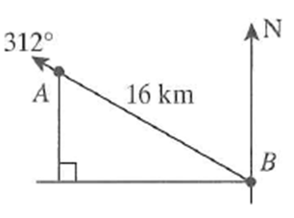

<_block>

[A] $10.71km$

<_block>

[B] $11.89km$

<_block>

[C] $13.57km$

<_block>

[D] $14.41km$

<_block>

[B]

<___question>

Type=1

<_block>

Which of these is the exact area of triangle *ABC* if

*a = 6cm, b =* *4cm, and angle C = 60°* ?

<_block>

[A] $6\sqrt{3cm²}$

<_block>

[B] $12\sqrt{3cm²}$

<_block>

[C] $24\sqrt{3cm²}$

<_block>

[D] $48\sqrt{3cm²}$

<_block>

[A]

<___question>

Type=1

<_block>

The capacity of a sphere is *36 $π L$*. Which of these is the surface area of the sphere?

<_block>

[A] *36 $π cm²$*

<_block>

[B] *64 $π cm²$*

<_block>

[C] *72 $π cm²$*

<_block>

[D] *108 $π cm²$*

<_block>

[A]

<___question>

Type=1

<_block>

If the slant height of the smaller cone is 16cm, what is the slant height of the larger cone?

<_block>

[A] $20cm$

<_block>

[B] $22.25cm$

<_block>

[C] $25cm$

<_block>

[D] $31.25cm$

<_block>

[A]

<___question>

Type=1

<_block>

Which of these is the size of Ѳ ?

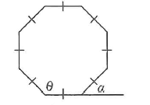

<_block>

[A] $105°$

<_block>

[B] $115°$

<_block>

[C] $125°$

<_block>

[D] $135°$

<_block>

[D]

<___question>

Tyep=1

<_block>

Which of these is the value of *x* ?

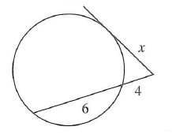

<_block>

[A] $2\sqrt{6}$

<_block>

[B] $4\sqrt{5}$

<_block>

[C] $2\sqrt{10}$

<_block>

[D] $10$

<_block>

[C]